
FACULTY OF ENGINEERING
DEPARTMENT OF PETROLEUM AND GAS ENGINEERING
A LABORATORY REPORT
ON THE EFFECT OF SAW DUST ON MUD WEIGHT
EXPERIMENT 5
GROUP 3

NAME: JOHN OGELLE IKECHI
STUDENT ID: 20222567
DEGREE PROGRAMME: B. Eng. PETROLEUM AND GAS ENGINEERING
LEVEL: 400L
COURSE CODE: PGE 415
ACADEMIC YEAR: 2025/2026 ACADEMIC SESSION
DATE: 11 NOVEMBER 2025

LIST OF FIGURE
Figure 1: Drilling Mud……………………………………………...………………………..11
Figure 2: Spatula……………………………………………………………………………..11
Figure 3: Beaker………………………………………….……………….…………………12
Figure 4: Mud Mixer………………………………………………………..……………….12
Figure 5: Mud Cup………………………………………………………….……………….12
Figure 6: Weight Scale……………………………………………………………………….12
Figure 7: Measuring Cylinder…………………………………………….…………………13
Figure 8: Bentonite Clay…………………………………………………………………….13
Figure 9: Saw Dust…………………………………………………………………………..13
Figure 10: Baroid Mud Balance………………………………….………………………….13
Figure 11: Graph of mud density (ppg) against saw dust (g)……………………………..…16

LIST OF TABLES
Table 1: Density Values from the experiment………………………………………………...15

INTRODUCTION

1.0 INTRODUCTION
Drilling mud is an essential component of oil and gas drilling operations, designed to serve multiple purposes, including maintaining hydrostatic pressure, stabilizing the wellbore, cooling and lubricating the drill bit, and suspending cuttings for removal (Rabia, 2001). One of the most critical properties of drilling mud is its density, or mud weight, which must be carefully controlled to balance formation pressures and prevent wellbore instability or blowouts.
Traditionally, barite and other high-density materials are used to increase mud weight, while water or oil can dilute it for lower-density mud. However, there is growing interest in alternative, environmentally friendly materials that can modify mud weight while also enhancing other properties of drilling fluids. Sawdust, a low-density, biodegradable material, has been investigated for its potential effects on drilling fluid properties, particularly its ability to reduce mud weight. This overview examines how sawdust influences mud weight, its potential benefits, and its broader applications in the oil and gas industry.
MUD WEIGHT
Mud weight or mud density is a weight of mud per unit volume. It is one of the most important drilling fluid properties because it controls formation pressure and it also helps wellbore stability. Mud weight is measured and reported in pounds per gallon (PPG), pounds per cubic feet (lb/ft3), or grams per milliliter (b/ml).
Mud weight forms an integral and vital component part in controlling the drilling operating window and wellbore pressure management requirements. It contributes to both direct and indirect indicators and is a key metric of the magnitude and extent of pressure and operating conditions that exist. Mud primarily provides the hydrostatic density and pressure as a function of vertical depth to support the range of wellbore formation pressures that exist in each section to be drilled. It serves to assure that no kicks, lost circulation, or wellbore instability events result in both static and dynamic operating conditions during all drilling operating activities conducted.

SAW DUST
Sawdust is a byproduct of cutting, grinding, drilling, or sanding wood and consists of fine particles or shavings. It has been historically considered waste material but has gained recognition for its utility in various industries, from agriculture to energy production. This article explores the characteristics, uses, and environmental implications of sawdust.
Composition and Properties
Sawdust is primarily composed of cellulose, hemicellulose, and lignin, which are the main components of wood. Depending on the type of wood, it may also contain small amounts of natural oils, resins, or chemical preservatives if derived from treated wood.
Key properties of sawdust include:
Lightweight and porous structure: This makes it useful as an absorbent material.
High carbon content: Contributing to its use as a fuel or in composting.
Varied particle size: Depending on the machining process and equipment used.
USES OF SAW DUST
An important thing to think about before using sawdust is the oil content.
We all use chain and bar oil in our chainsaws or mills and this is distributed through the sawdust. If you are not using a biodegradable or alternative bar and chain oil like vegetable oil then a lot of people say it’s no good for anything.
- Compost
Adding sawdust to your compost is another good use for it. Putting too much of it in is not advisable because of the oil content and it can decrease the nitrogen levels in the soil. However, it is also advisable to add horse manure and chicken poo to the compost so that aids combat any problems there.
Compost full of waste like lawn clippings and vegetable greens (broccoli plants, for example) which also help to increase nitrogen levels. Sawdust is just another ingredient that enriches your compost when used in the right amounts.
- Straight into the soil
In some parts of the garden, it might make sense to add sawdust right into the soil. Some greenhouses have really high nitrogen levels, or could be cause from adding too much chicken poo to the soil. Adding a bit of sawdust helps in leveling things out a bit.
- Mop up oil
One of the most practical uses for sawdust is to soak up any oil or fuel spills. It’s great for those larger spills as it really does just soak it right up. Once you’ve applied enough sawdust and left it a little while, it can easily be swept up and put in the trash. Sawdust is very absorbent so could be used for a range of clean-up tasks similar to this as well.
- Dry out paint
If you have old paint you want to get rid of, you are supposed to dry it out first. Runny paint is apparently more toxic than dry paint.
Some manufacturer instructions say to brush out unwanted paint onto newspaper, let it dry, and then throw it away.
An alternative is to add sawdust or wood shavings to unwanted paint. This soaks up the moisture and will harden the paint up quickly. It’s then able to be disposed of in the trash.

1.1. SIGNIFICANCE OF STUDY
The study of sawdust as an additive to modify mud weight is significant due to its potential environmental, operational, and economic benefits:
1. Environmental Sustainability
Sawdust is a byproduct of the timber industry and other wood-processing activities. Its use in drilling mud not only provides an avenue for waste management but also reduces reliance on non-biodegradable additives, aligning with global efforts to minimize the environmental impact of oil and gas exploration (Sharma et al., 2012).

2. Cost Reduction
Compared to conventional weighting agents like barite, sawdust is inexpensive and readily available in large quantities. Incorporating sawdust into drilling mud could significantly lower costs, particularly for operations requiring large volumes of lightweight drilling fluids (Bourgoyne et al., 1986).
3. Lightweight Mud Formulations
Sawdust can reduce the density of drilling fluids, making it suitable for drilling in low-pressure formations or fragile zones. Such formations are prone to fractures or fluid loss if exposed to higher-density muds. By decreasing mud weight, sawdust-based formulations can prevent formation damage and improve wellbore stability (Rabia, 2001).
4. Rheological and Filtration Properties
Apart from its impact on mud weight, sawdust may enhance the rheological properties of drilling mud, improving its capacity to suspend and transport cuttings. It can also reduce fluid loss by forming a filter cake on the wellbore wall, which helps prevent differential sticking and formation damage (Shah et al., 2011).

1.2. APPLICATION OF STUDY
The findings on the effects of sawdust on mud weight and its associated properties have several practical applications across various phases of drilling operations:
1. Drilling in Fragile or Low-Pressure Formations
In drilling through weak or highly depleted formations, the use of lightweight drilling muds is essential to avoid issues such as lost circulation or wellbore instability. Sawdust-modified mud can provide a viable solution by lowering the mud weight to levels that are compatible with such formations.
2. Enhanced Environmental Performance
Using sawdust as a biodegradable additive reduces the environmental footprint of drilling operations. By replacing or complementing synthetic additives, sawdust contributes to cleaner drilling practices and facilitates easier disposal of used drilling mud (Sharma et al., 2012).

3. Waste Management
Sawdust represents a sustainable way to recycle wood waste from the timber and furniture industries. Its use in drilling mud converts waste material into a valuable resource, aligning with circular economy principles.
4. Economic Benefits
The cost-effectiveness of sawdust compared to traditional weighting agents like barite makes it attractive for reducing overall drilling fluid costs. This is particularly advantageous in operations where mud weight adjustments are frequent or where the use of lightweight muds is necessary.
5. Compatibility with Other Additives
Sawdust can be used in combination with other drilling fluid additives to achieve desired properties. For example, it can be blended with polymers or clays to fine-tune the rheological and filtration characteristics of the mud. This versatility makes it a promising component in modern drilling fluid systems (Rabia, 2001).
6. Field Applications in Extended-Reach Drilling
In extended-reach drilling, where wellbore pressure gradients vary significantly, maintaining the appropriate mud weight is critical. Sawdust-modified drilling fluids can provide a flexible and adaptable solution, ensuring stable drilling performance across varying downhole conditions.

AIMS AND OBJECTIVES
2.1 AIMS
- To identify the effects of saw dust on the density of drilling mud
2.2 OBJECTIVES
- To prepare water-based drilling mud.
- To gain an understanding on the importance of density during drilling operations
- To study the relationship between amounts of mud density additives and mud weight.
- To learn how to calibrate a mud balance.
- Plot a graph of PPG against grams
- Using the graph, interpolate and get the PPG at 15

3.0 EXPERIMENTAL APPARATUS
- Water
- Bentonite clay
- Saw dust
- Mud mixer
- Spatula
- Mixer cup
- Beaker Measuring cylinder
- Stopwatch
- Electrical weighing balance.
- Mud balance

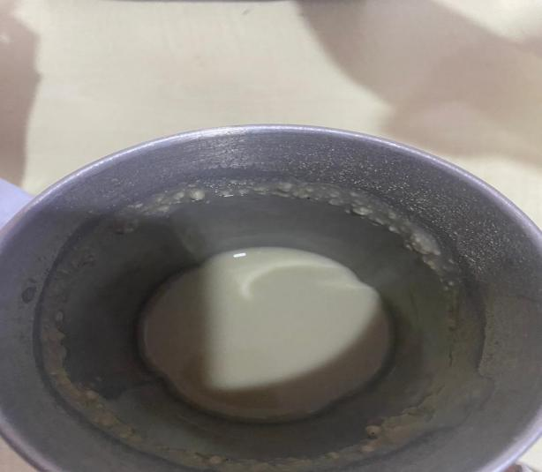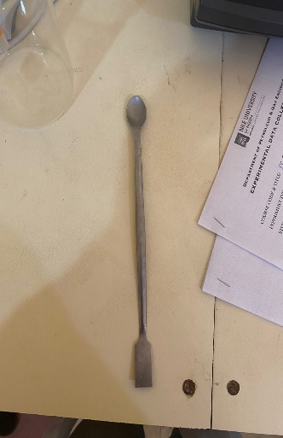
Figure 1: Drilling Mud Figure 2: Spatula
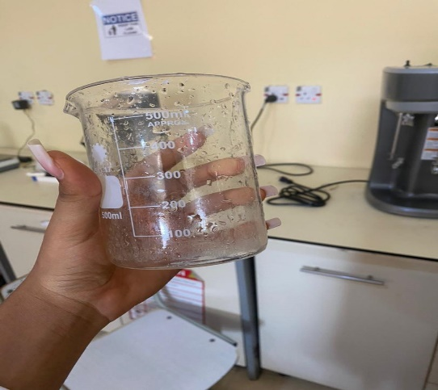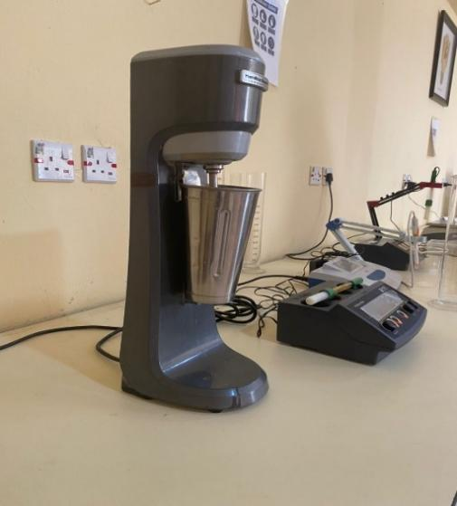
Figure 3: Beaker Figure 4: Mud Mixer

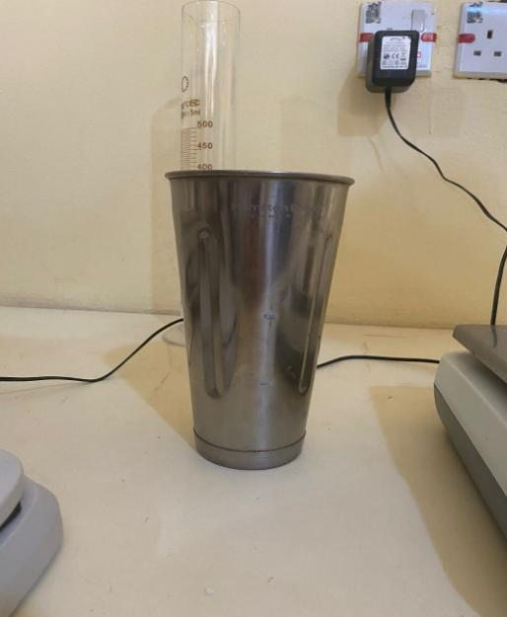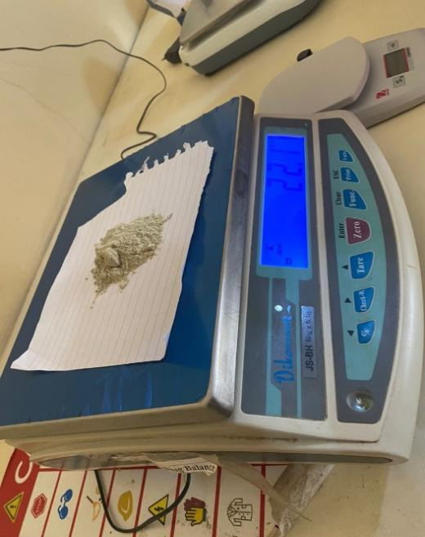
Figure 5: Mud Cup Figure 6: Weight Scale

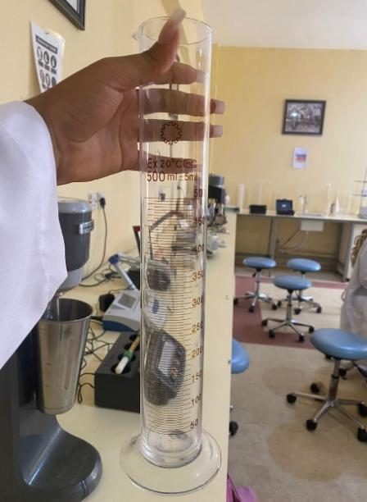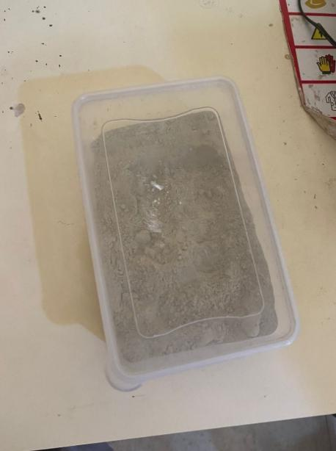
Figure 7: Measuring Cylinder Figure 8: Bentonite Clay

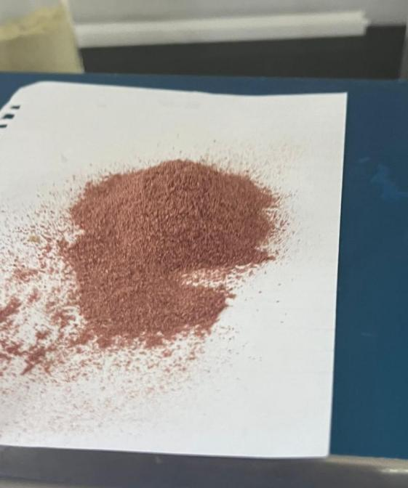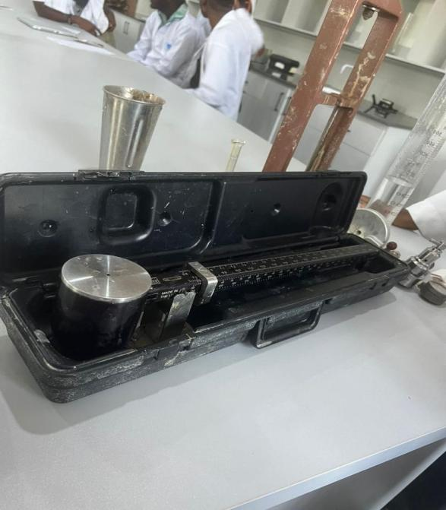
Figure 9: Saw Dust Figure 10: Baroid Mud Balance

4.0 EXPERIMENTAL PROCEDURES
Preparation of drilling mud
- 22g of Bentonite clay was measured with the weight balance (Plane paper was placed on the weight balance and the clay was gradually poured on top till it reached 22g).
- 350 ml of water was measured using a measuring cylinder.
- Mud cup was obtained and 350 ml of water was poured into the mud cup and it was carefully placed on the mixer.
- The mud mixer was turned on.
- As it was turning, the bentonite clay was gradually poured in with a spatula and after all the clay was in, a timer was set to 5 minutes.

Addition of saw dust
- 5g of sand dust was added into the drilling the mud
- Some of the mixture was poured into a 4 scale mud balance cup until it’s Filled
- The lid of the mud balance cup was covered
- The rider of the mud balance was adjusted until it’s at equilibrium
- The readings in ppg, sg, lb/ft3, psi/1000ft was obtained
- Procedures 13-17 was repeated with 10g of sand dust
RESULT

5.0 RESULT
The experiment was aimed to observe the effect of adding sawdust to drilling mud on its density. The density was measured in various units, including specific gravity (SG), pounds per gallon (ppg), pounds per cubic foot (lb/ft³), and pounds per square inch per 1000 feet (psi/1000 ft).
Below is the table of the values of the density of the drilling mud when no saw dust was added, 5g of saw dust, etc.
Table 1: Density Values from the experiment
S/N | Saw Dust (g) | SG | PPG | Ib/ft³ | Psi/1000ft
1 | 0 | 1.045 | 8.71 | 65.1 | 455
2 | 5 | 1.04 | 8.64 | 65.0 | 452
3 | 10 | 1.005 | 8.45 | 63.0 | 438
4 | 15 | 1.007 | 8.40 | 62.52 | 437
5 | Water | 1.0 | 8.3 | 62.0 | 435

From the table above, As the amount of sawdust increased, the density of the drilling mud decreased. This is likely due to the lower density of sawdust compared to the base mud. The specific gravity, which is the ratio of the density of the substance to the density of water, also decreased with increasing sawdust content.
A similar trend is observed in the ppg values, which also decreased with increasing sawdust. The lb/ft³ values, which represent the weight of the mud per unit volume, also decreased with increasing sawdust content. This unit, often used in drilling engineering, also shows a decrease with increasing sawdust content. This reduction in pressure could potentially impact the drilling process, especially in high-pressure environments.

6.0 DISCUSSION OF RESULTS
Sawdust, a readily available and relatively inexpensive material, can potentially be used as a density-reducing agent in drilling mud.
It can help to optimize mud weight for specific drilling conditions, such as in soft formations or where reduced formation pressure is desired.
How Sawdust Affect Mud Density.
Sawdust is less dense than the typical components of drilling mud, such as barite or hematite.
By adding sawdust, the overall density of the mud is reduced, as the lighter sawdust particles displace the heavier mud components.
Benefits of Using Sawdust as a Mud Additive
Cost Reduction: Sawdust can be a more economical alternative to traditional weighting agents, especially in regions where sawdust is readily available.
Environmental Impact: Sawdust, being a natural material, may have a lower environmental impact compared to synthetic additives.
Disadvantages of Using Sawdust
Filtration Properties: Sawdust particles may affect the filtration properties of the mud, potentially leading to increased fluid loss and formation damage.
Rheological Properties: The addition of sawdust could alter the rheological properties of the mud, impacting its ability to suspend drill cuttings and maintain borehole stability.
Particle Size Distribution: The particle size distribution of the sawdust can influence its impact on mud properties. Finer particles may have a greater effect on density, while coarser particles may affect filtration and rheology.

How Sawdust Concentration Affect Mud Density
As the concentration of sawdust increases, the density of the mud decreases. However, there may be a limit to the amount of sawdust that can be added before it starts to negatively impact the mud's performance.
Other Factors that Influence the Effect of Sawdust
The type of base mud, the specific properties of the sawdust, and the drilling conditions can all influence the impact of sawdust on mud density and performance.
For example, the moisture content of the sawdust and its particle size distribution can affect its effectiveness as a density-reducing agent.

CONCLUSION AND RECOMMENDATION
7.1 CONCLUSION
The results of this experiment have shed light on sawdust's potential as an economical and sustainable addition. According to the findings, the density of the mud decreases as the sawdust concentration rises.
But it's important to think about how sawdust might affect other mud characteristics like stability, filtration, and rheology.
7.2 RECOMMENDATIONS
Based on the results of this experiment, here are some of my recommendations:
- Rigorous laboratory and field tests should be conducted to determine the optimal concentration of sawdust for specific drilling conditions.
- The impact of different sawdust particle sizes on mud properties should be investigated.
- A comprehensive environmental impact assessment should be conducted to evaluate the potential risks associated with using sawdust in drilling operations.
- Strict quality control measures should be implemented to ensure the consistent quality and performance of sawdust-based muds.

REFERENCES
Adebayo Thomas Ayotunde, & Chinonyere Precious C. (2012). Sawdust As A Filteration Control And Density Additives in Water-Based Drilling Mud. International Journal of Scientific and Engineering Research, 3(7), 2229–5518. https://www.researchgate.net/publication/241186085_Sawdust_As_A_Filteration_Control_And_Density_Additives_in_Water-Based_Drilling_Mud
Chen, J. (n.d.). Drilling Mud Definition. Investopedia. https://www.investopedia.com/terms/d/drillingmud.asp
Daniel. (2023, November 22). 10 BEST Uses For Sawdust: How To Use Sawdust Around Home. Fire and Saw. https://fireandsaw.com/uses-for-sawdust/
Mud Weight - an overview | ScienceDirect Topics. (n.d.). Www.sciencedirect.com. https://www.sciencedirect.com/topics/engineering/mud-weight
Queeni, C. (2024, March 10). What are drilling fluids : types, composition & uses. LearnToDrill. https://www.learntodrill.com/post/drilling-fluids-types
Bourgoyne, A. T., Millheim, K. K., Chenevert, M. E., & Young, F. S. (1986). Applied Drilling Engineering. Society of Petroleum Engineers.
.

